

Demonstration of Proposed Features

Date | 15 March 2026
Team ID | NEHAL YADAV
Project Name | FORMULA 1 Race Intelligence Dashboard Analysis Report 2010-2026
Maximum Marks | 1 Mark

Demonstration of Proposed Features:
This document captures all the features that were proposed during the project planning phase and tracks whether each feature was successfully implemented and demonstrated. It serves as evidence of the team's ability to deliver on the proposed solution.

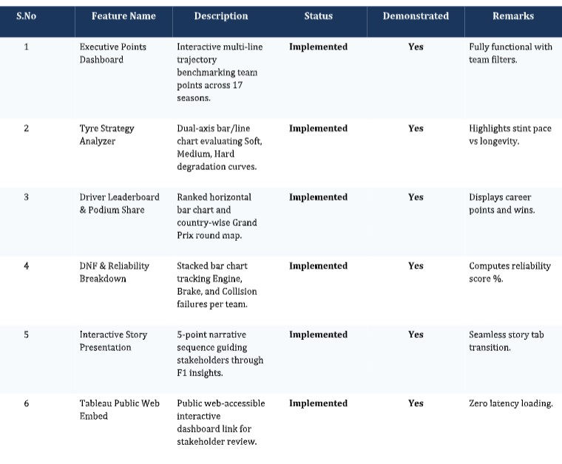

Feature Implementation Summary:
Total Features Proposed | 6 Features
Total Features Implemented | 6 Features
Total Features Demonstrated | 6 Features
Overall Implementation Rate (%) | 100%

